Name : Tushar Pathak
RegNumber : 230905396
Roll Number: B48

Lab 6: Programs for Array in CUDA

Q1). Write a program in CUDA which performs convolution operation on ID input array of size N amd width using a mask arrary M of size mask_width to produce the resultant one dimensional airny P of size width.

Code:
#include <stdio.h>
#include <cuda.h>

__global__ void convolution1D(float *N, float *M, float *P,
int width, int mask_width) {

int i = blockIdx.x * blockDim.x + threadIdx.x;
int half = mask_width / 2;

if (i < width) {
float sum = 0.0f;

for (int j = 0; j < mask_width; j++) {
int idx = i - half + j;
if (idx >= 0 && idx < width)
sum += N[idx] * M[j];
}
P[i] = sum;
}
}

int main() {

int width, mask_width;

printf("Enter size of input array: ");
scanf("%d", &width);

printf("Enter size of mask: ");
scanf("%d", &mask_width);

float *h_N = (float*)malloc(width * sizeof(float));
float *h_M = (float*)malloc(mask_width * sizeof(float));
float *h_P = (float*)malloc(width * sizeof(float));

printf("Enter input array elements:\n");
for (int i = 0; i < width; i++)
scanf("%f", &h_N[i]);

printf("Enter mask elements:\n");
for (int i = 0; i < mask_width; i++)
scanf("%f", &h_M[i]);

float *d_N, *d_M, *d_P;

cudaMalloc(&d_N, width * sizeof(float));
cudaMalloc(&d_M, mask_width * sizeof(float));
cudaMalloc(&d_P, width * sizeof(float));

cudaMemcpy(d_N, h_N, width * sizeof(float), cudaMemcpyHostToDevice);
cudaMemcpy(d_M, h_M, mask_width * sizeof(float), cudaMemcpyHostToDevice);

dim3 blockDim(256);
dim3 gridDim((width + blockDim.x - 1) / blockDim.x);

convolution1D<<<gridDim, blockDim>>>(d_N, d_M, d_P, width, mask_width);

cudaMemcpy(h_P, d_P, width * sizeof(float), cudaMemcpyDeviceToHost);

printf("Resultant array:\n");
for (int i = 0; i < width; i++)
printf("%f ", h_P[i]);

cudaFree(d_N); cudaFree(d_M); cudaFree(d_P);
free(h_N); free(h_M); free(h_P);

return 0;
}

Output :
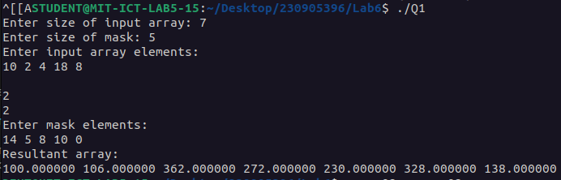

Q2)Write a program in CUDA to perform selection sort in parallel.
Code:
#include "cuda_runtime.h"
#include "device_launch_parameters.h"
#include <stdio.h>
#include <stdlib.h>

__global__ void selsort(int *a, int *b, int n){
int tid = blockIdx.x*blockDim.x + threadIdx.x;
int pos = 0;
int data = a[tid];
for(int i=0; i<n; i++){
if(i == tid)continue;
if(a[i] < data || (a[i]==data && i<tid))pos++;
}
b[pos]=data;
}

int main(void) {
int n;
int *h_a, *h_b, *d_a, *d_b;

printf("Enter size of array");
scanf("%d", &n);

int size = n * sizeof(int);

h_a = (int*)malloc(size);
h_b = (int*)malloc(size);

printf("Enter array elements:\n");
for(int i = 0; i < n; i++)
scanf("%d", &h_a[i]);;

cudaMalloc((void **)&d_a, size);
cudaMalloc((void **)&d_b, size);

cudaMemcpy(d_a, h_a, size, cudaMemcpyHostToDevice);

dim3 dimGrid(ceil(n/256.0), 1, 1);
dim3 dimBlock(256, 1, 1);
selsort <<< dimGrid, dimBlock >>> (d_a, d_b, n);
cudaMemcpy(h_b, d_b, size, cudaMemcpyDeviceToHost);
printf("Resultant sorted array is:\n");
for(int i = 0; i < n; i++)
printf("%d ", h_b[i]);
printf("\n");

cudaFree(d_a); cudaFree(d_b);
free(h_a); free(h_b);
return 0;
}
Output:

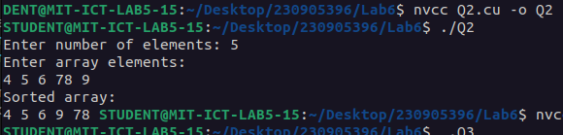

Q3)Write a program in CUDA to perforn odd even transposition sort in parallel.
Code:
#include <stdio.h>
#include <cuda.h>
#include <stdlib.h>

__global__ void evenPhaseKernel(int *arr, int n) {

int tid = blockIdx.x * blockDim.x + threadIdx.x;
int i = 2 * tid; // even index

if (i + 1 < n) {
if (arr[i] > arr[i + 1]) {
int temp = arr[i];
arr[i] = arr[i + 1];
arr[i + 1] = temp;
}
}
}

__global__ void oddPhaseKernel(int *arr, int n) {

int tid = blockIdx.x * blockDim.x + threadIdx.x;
int i = 2 * tid + 1; // odd index

if (i + 1 < n) {
if (arr[i] > arr[i + 1]) {
int temp = arr[i];
arr[i] = arr[i + 1];
arr[i + 1] = temp;
}
}
}

int main() {

int n;

printf("Enter number of elements: ");
scanf("%d", &n);

int *h_arr = (int*)malloc(n * sizeof(int));

printf("Enter array elements:\n");
for (int i = 0; i < n; i++)
scanf("%d", &h_arr[i]);

int *d_arr;
cudaMalloc(&d_arr, n * sizeof(int));
cudaMemcpy(d_arr, h_arr, n * sizeof(int), cudaMemcpyHostToDevice);

// Number of comparison pairs ≈ n/2
dim3 blockDim(256);
dim3 gridDim((n/2 + blockDim.x - 1) / blockDim.x);

// Perform n phases
for (int i = 0; i < n; i++) {

if (i % 2 == 0)
evenPhaseKernel<<<gridDim, blockDim>>>(d_arr, n);
else
oddPhaseKernel<<<gridDim, blockDim>>>(d_arr, n);

cudaDeviceSynchronize();
}

cudaMemcpy(h_arr, d_arr, n * sizeof(int), cudaMemcpyDeviceToHost);

printf("Sorted array:\n");
for (int i = 0; i < n; i++)
printf("%d ", h_arr[i]);

cudaFree(d_arr);
free(h_arr);

return 0;
}

Output:
